REPORT

The assignment includes four parts. Each of the questions are solved using pixel values of the image. The different parts are explained as follows:

1. **Create a brightness adjusted image B1 from the image I by adding a constant factor 50.**  
   An 8-bit RGB image has 3 channels corresponding to the three colors-Red, Green and Blue. In order to increase the brightness of the image, a constant factor 50 is added to each of the colors, for each pixel.  
   That is, at a particular pixel,  
    Value of R/G/B in new image = Value of R/G/B in original image + 50  
     
   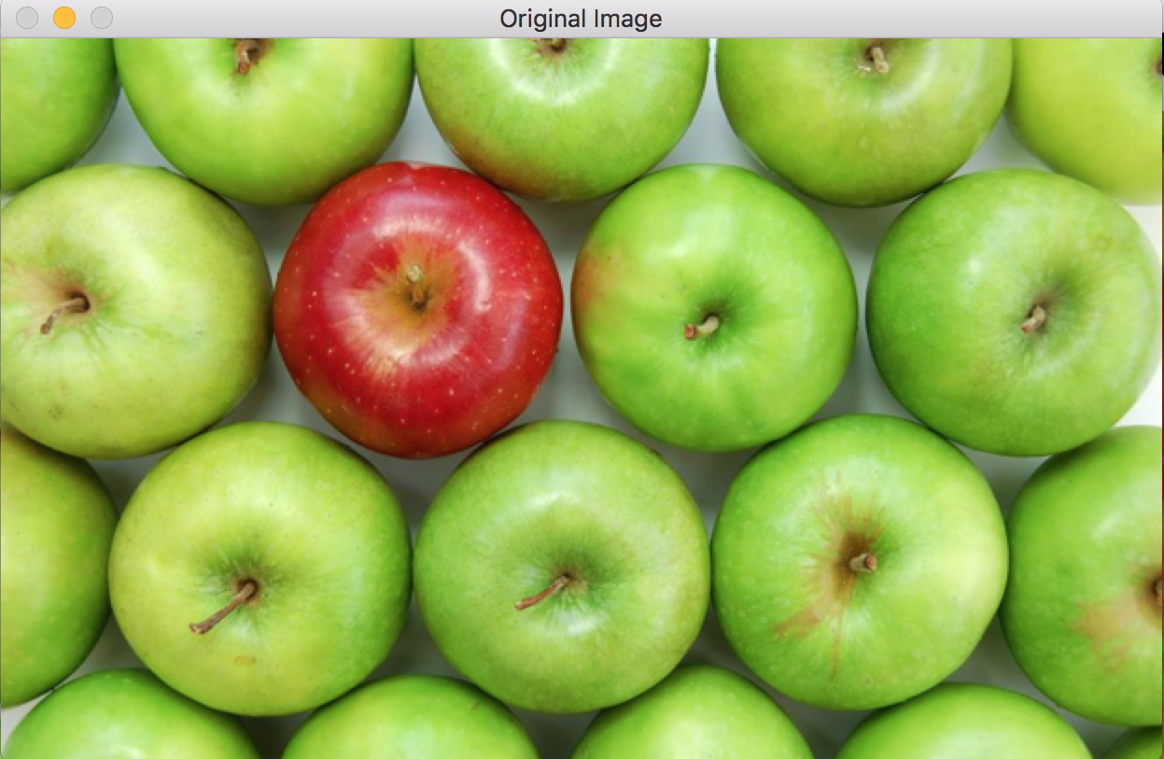  
     
   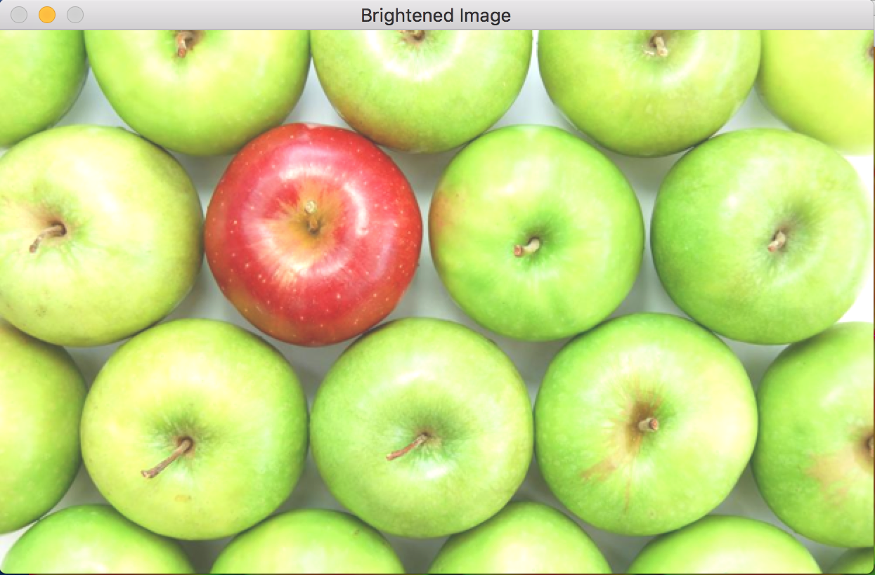
2. **Convert both images from RGB to HSV color space.**

In order to do the conversion using pixel values, the following steps are performed:

* + 1. Since R, G and B values range from 0 to 255, they are converted to floating point values (ranging between 0.0 and 1.0) by dividing it by 255 and type casting it.
    2. Values of HSV are obtained by using the following formulas.  
        V= max(R, G, B); where 0 <= V <= 1  
          
        S=0 if V=0 where 0 <= S <= 1  
        S= (V-min(R, G, B)) / V otherwise

H=60 * (G-B) / (V-min(R, G, B)) if V=R

H =120 + 60 * (B-R) / (V-min(R, G, B)) if V=G

H = 2400 + 60 * (R-G) / (V-min(R, G, B)) if V=B

If H < 0 then H + 360 where 0 <= H <= 360

* + 1. The values are then converted to fit within the range of 0 and 255, that is the data type of the 8-bit destination image   
       V = 255 * V  
       S = 255 *S  
       H = H / 2  
         
       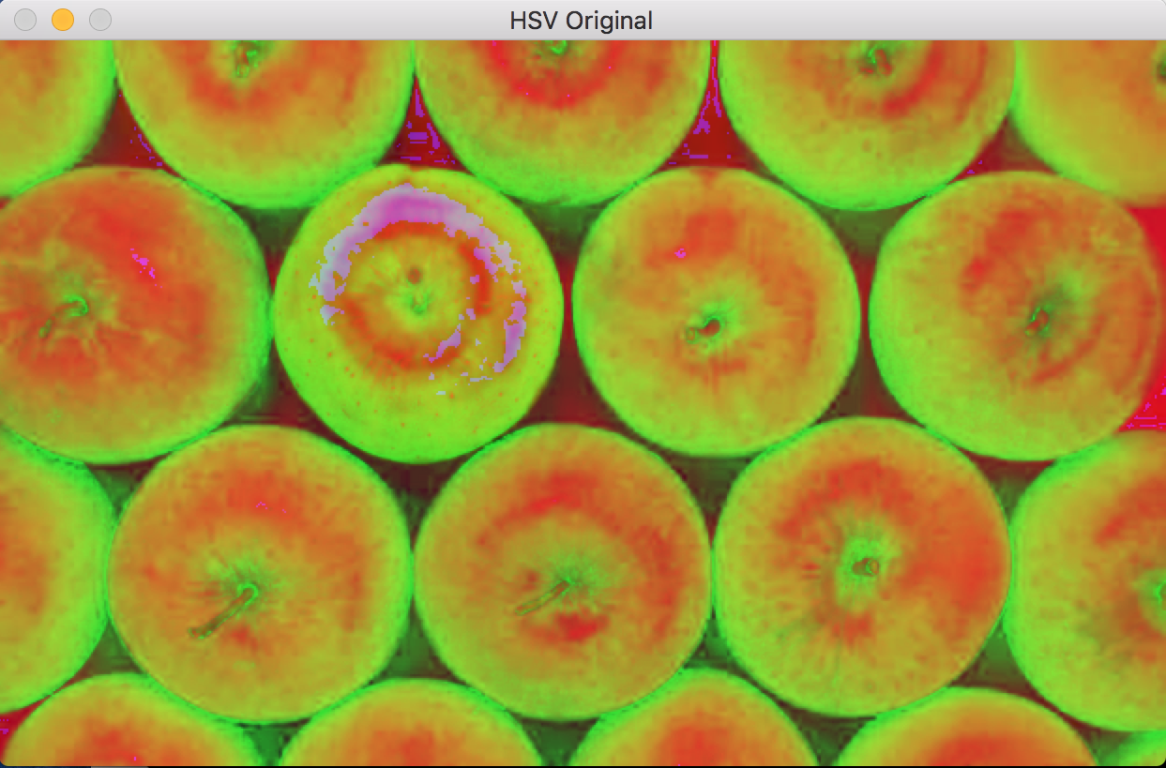  
         
       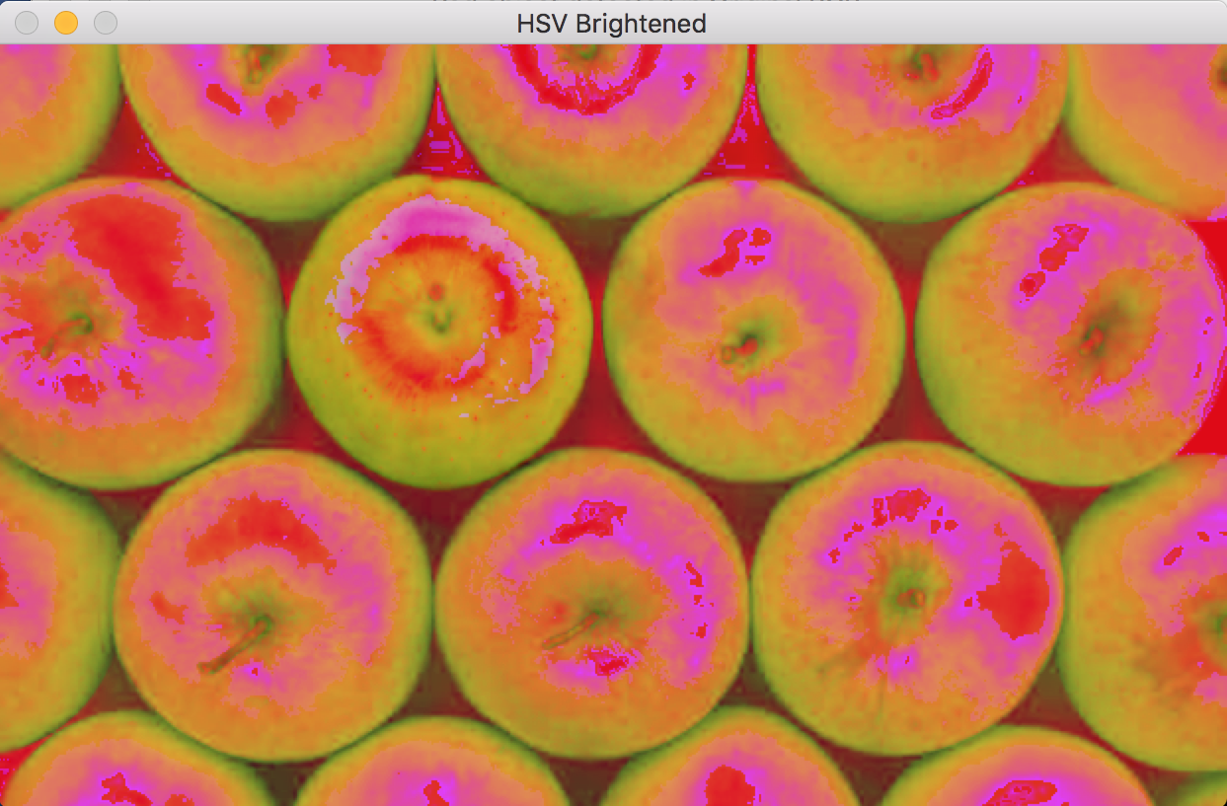

1. **Find the “red apple” in each image using both of the following methods and mark the apple with a bounding circle/box**In both cases, the object is detected using a threshold value for R, G and B components. If the pixel value lies within this threshold, the pixel in the new image is assigned as white. Otherwise, it is assigned as black.  
     
   In order to draw the bounding box, we find the (x, y) coordinates of the top most, left most, bottom most and right most pixel of the red apple. These coordinates are then used as input to a **rectangle** function that is provided by OpenCV.i) Object detection in RGB Domain  
      
    Original:  
    Threshold values are, R >= 115 , G <= 65 , B <= 70  
    Brightened:   
    Threshold values are, R >= 165 , G <= 115 , B <= 120  
   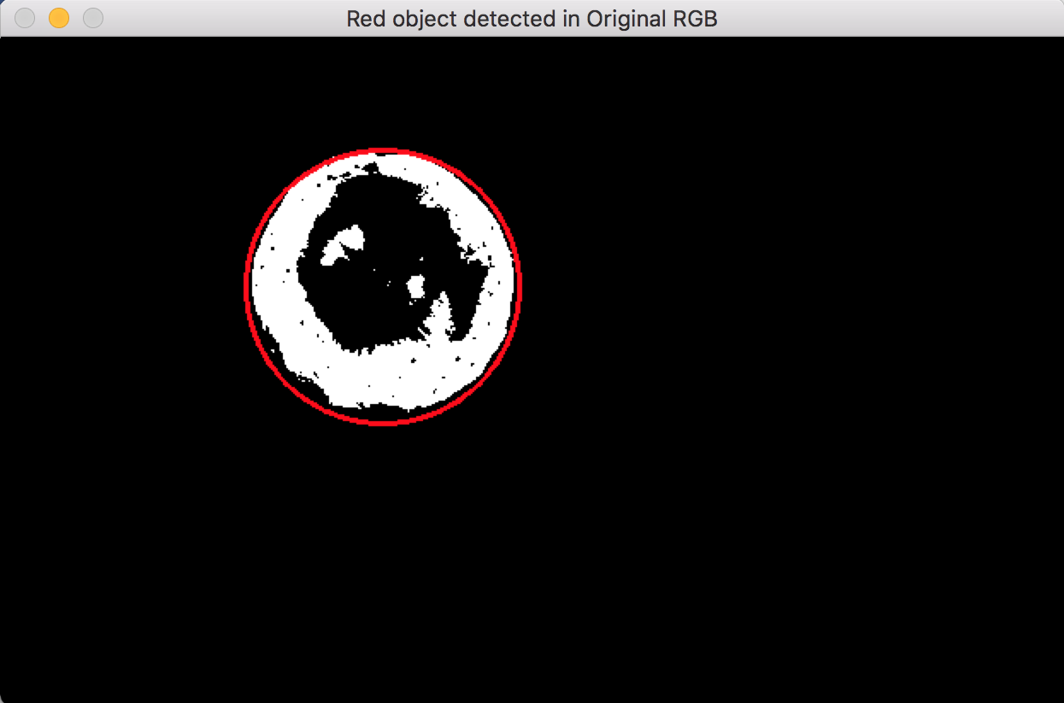  
     
   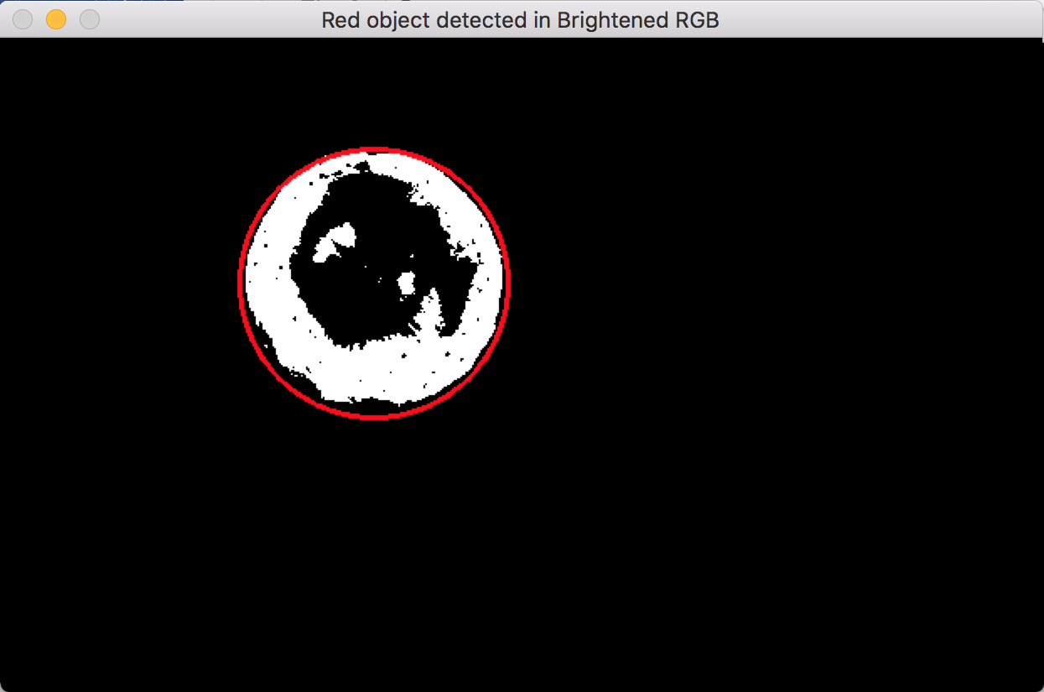  
     
   ii) Object detection in HSV Domain  
     
    Original and Brightened:  
    Threshold values are, H <= 10 or 170 <= H <= 180 , S >= 80 , V >= 70   
   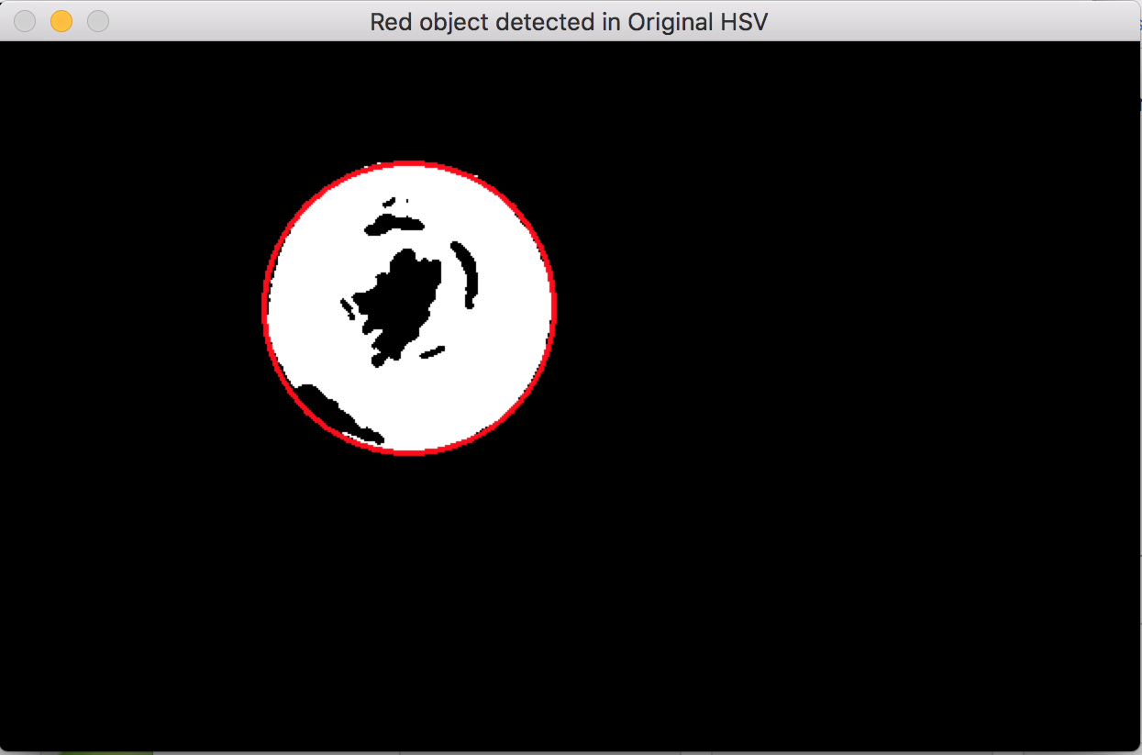  
     
   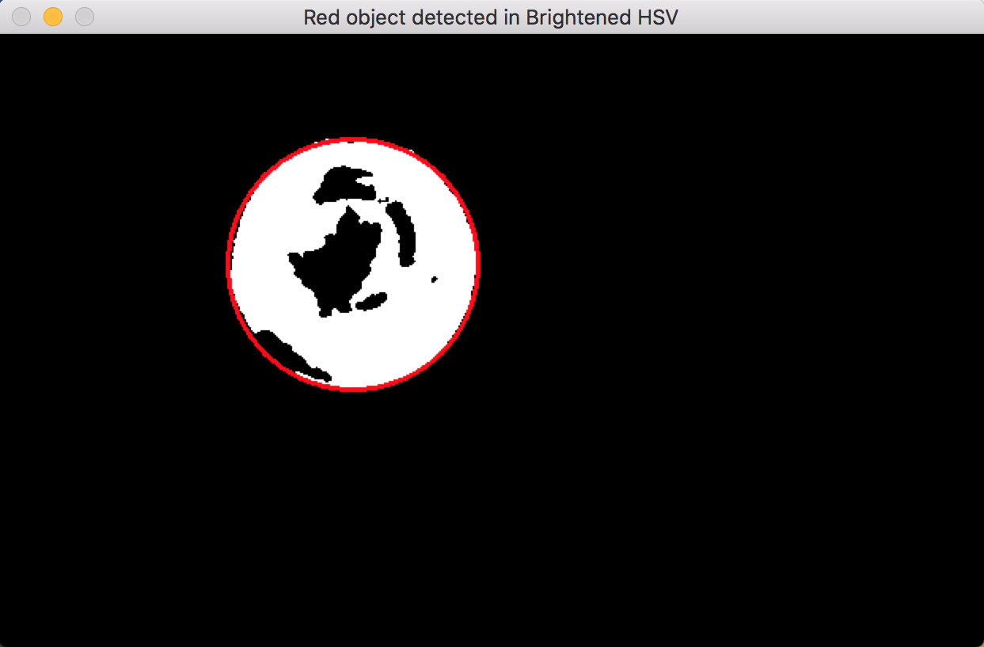
2. **Convert the red apple into a green apple and vice versa.**In this case, colors are swapped by modifying the pixel values. For each pixel in the image, swap the values of green and red components.  
     
   